1. Definitions and implications:

The following definitions come from the international energy agency[1]: “Grey” hydrogen is defined as hydrogen whose production releases carbon emissions into the atmosphere, the most common example is hydrogen produced from Natural gas. “Blue” hydrogen is defined as hydrogen which generates carbon emissions but captured, CCUS (carbon capture utilization and storage). The stored carbon can then be used for some other process for some other process. The cost of CCUS[2] is estimated to 50 to 70 euros per ton of CO2. “Green” hydrogen is hydrogen whose production creates no carbon emissions.

Note that Green hydrogen is defined through the production process while grey and blue hydrogen are concepts which are defined conditional on a production process, specifically, conditionally on the fact that carbon emissions are generated but are differentiated depending on what happens to the carbon emissions generated.

Why are these definitions useful? It can be seen that since “blue” hydrogen is an extra step in the production process and not a specific way of producing, that “blue” hydrogen can never have a lower market price than “grey” hydrogen which has fewer steps. There are only two possibilities for “blue“ hydrogen to have a lower market price than “grey” hydrogen, either a carbon tax on carbon *emitted* or technology that significantly increases the value of stored carbon significantly, which, so far, has low prospects.

This means that the only feasible future where the majority of hydrogen production does not emit carbon into the atmosphere is Green hydrogen. The non-policy ways the majority of hydrogen can be green are either an increase in the value of stored carbon is an increase in the costs of the inputs of grey hydrogen, such as natural gas (which is expected to increase) or consumer demand for “green products”.

Notice that fluctuations in the inputs of grey hydrogen do not make “blue” hydrogen more attractive relative to grey hydrogen because their cost of production rises by the same amount. An increase in the prices inputs to grey/blue hydrogen does on the other hand make “green” hydrogen relatively more attractive. On the other hand, supporting CCUS technologies will necessarily decrease the relative attractiveness of Green technology, as well as new discoveries for stored carboge[3]. Clean energy production, is the main method by which green hydrogen can become the dominant form.

1. Benefits:

The European Commission’s arguments for clean energy are the benefits of decentralization through the use local energy sources, which have the following advantages[4]:

Primary benefits:

* Increased local energy security: the European commission estimates that by 2030, clean energy sources will decrease total European imports by 58billion per year [5]
* Market integration: Renewables will be able to have costs comparable with other forms of energy creation competition and increasing market efficiency.
* Energy efficiency: By reducing transportation distances and hence transmission losses, renewable energy can reduce primary energy consumption and improve the energy performance of buildings.
* Decarbonization: Renewables will reduce greenhouse gas emissions and therefore decrease all problems associated with their use.
* Innovation: EU has 30% of renewable patents; this represents an opportunity the geopolitical importance of the EU.

Secondary Benefits:

* Growth: The renewables industry is set to be over 1 trillion a year after 2030.
* Jobs: By 2014, the European commission estimated that renewables contributed 1million.
* Clean air: Relying on renewables is expected to contribute to clean atmosphere through numerous channels. This is estimated to reduce pre-mature deaths by 1.5 million[6]
* Cleaner oceans: The European commission has set a target of classifying 30% of coastal ecosystems as protected areas.[7]

The expected contribution of Hydrogen to these goals is summarized by the graph below: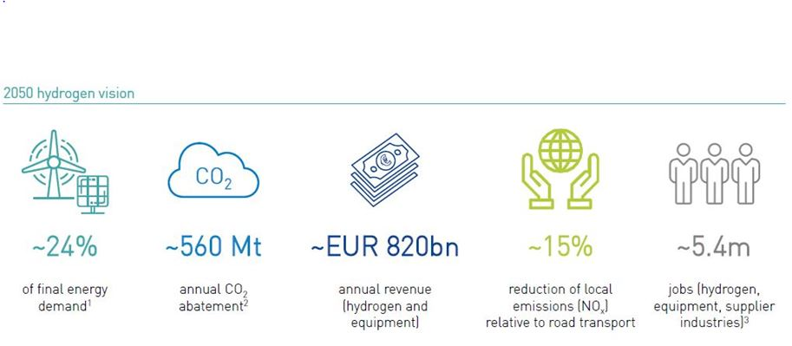

1. Progress:

The IEA 2019 Energy report finds that renewables have been lagging behind[8]

1. https://www.iea.org/commentaries/the-clean-hydrogen-future-has-already-begun
2. https://ec.europa.eu/jrc/en/research-topic/carbon-capture-utilisation-and-storage
3. For details on the possibilites of carbon capute see : https://www.iea.org/reports/putting-co2-to-use
4. https://eur-lex.europa.eu/legal-content/EN/TXT/PDF/?uri=CELEX:32009L0028&from=EN
5. https://ec.europa.eu/energy/topics/renewable-energy/progress-reports_en
6. https://www.iea.org/reports/world-energy-model/sustainable-development-scenario
7. P9_TA(2020)0005 The European Green Deal European Parliament resolution of 15 January 2020 on the European Green Deal (2019/2956(RSP))
8. https://www.iea.org/reports/tracking-power-2019/renewable-power